|  |
| --- |
| Difference Between NAAC & NBA Accreditation - Haq Se EngineerPREC LONIJai Shriram Engineering College (@JSREC09) / Twitter**JAI SHRIRAM ENGINEERING COLLEGE**  **TIRUPPUR – 638 660**  Approved by AICTE, New Delhi & Affiliated to Anna University, Chennai  Recognized by UGC & Accredited by NAAC and NBA (CSE and ECE) |

**DEPARTMENT OF**

**ELECTRONICS AND COMMUNICATION ENGINEERING**

**IBM - Naan Mudhalvan**

**Internet of Things**

**GROUP 3**

**Phase 4 - Project Submission**

**SMART PUBLIC RESTROOM**

**NAME : MANIVEL SHANKAR P**

**NM ID :AU711221106015**

**YEAR : III**

**SMART PUBLIC RESTROOM**

**Project code**

#include<ESP32Servo.h>

#define TRIGGERPIN 32

#define ECHOPIN 35

#define RED_LED 33

#define GREEN_LED 25

Servo servo_1;

long duration;

int pos, distance, i=0;

void setup()

{

servo_1.attach(18);

Serial.begin(115200);

pinMode(TRIGGERPIN, OUTPUT);

pinMode(ECHOPIN, INPUT);

pinMode(RED_LED, OUTPUT);

pinMode(GREEN_LED, OUTPUT);

Serial.println(" ");

Serial.println("Sensing the Height");

digitalWrite(RED_LED, HIGH);

digitalWrite(GREEN_LED, LOW);

pos = 0;

servo_1.write(pos);

}

void loop()

{

digitalWrite(TRIGGERPIN, LOW);

delayMicroseconds(3);

digitalWrite(TRIGGERPIN, HIGH);

delayMicroseconds(12); // it may be 10 us

digitalWrite(TRIGGERPIN, LOW);

// Reads the echoPin, returns the sound wave travel time in microseconds

duration = pulseIn(ECHOPIN, HIGH);

// Calculating the distance

distance = (duration/2) / 29.1;

// for Adult

if (distance >= 100 && distance <= 150)

{

i = 1;

if (pos != 180)

{

servo_1.write(180);

pos = 180;

i = 1;

}

}

// for Child

else if (distance >= 200 && distance <= 250)

{

i = 1;

if (pos != 0)

{

servo_1.write(0);

pos = 0;

i = 1;

}

}

else if (distance > 300 && i == 1)

{

digitalWrite(RED_LED, LOW);

digitalWrite(GREEN_LED, HIGH);

delay(5000);

digitalWrite(RED_LED, HIGH);

digitalWrite(GREEN_LED, LOW);

i = 0;

}

delay (500);

Serial.println(" ");

Serial.print("Free Level : ");

Serial.print(distance);

Serial.print(" ");

Serial.print("Position : ");

Serial.print(pos);

delay (500);

}

**Simulated Image**

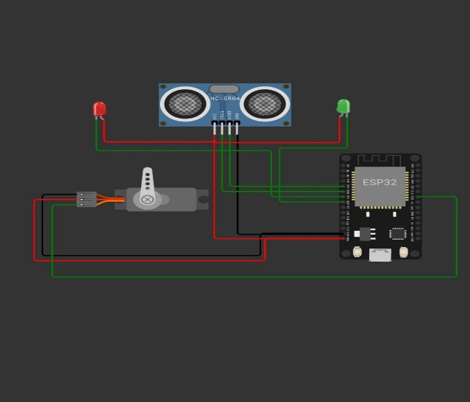

**Componenets used**

**Ultrasonic Sensor**

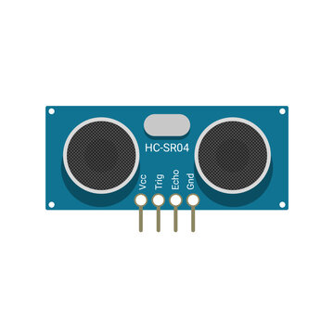Ultrasonic range modules HC SR04 provides 2cms to 400cms noncontact dimension functions, the range correctness can be reached to the 3mm. The module includes ultrasonic transmitters and receivers and the control circuits. Using the IO trigger for at least 10us high-level signal. The Module automatically sends eight, forty kilo Hertz and the detect whether there is a beat signal back. It usessonar to determine distance of an object. It offers excellent non-contact range detection with high accuracy and stable readings. Its operating range is from 2cm to 400cm. Thesensor module consists of 4 pins: VCC, GND, Trig, Echo.Trig is an input pin always provides with high pulse. When the sensor detects ultrasonic from receiver, it will set the Echo pin high and delay for a period(width) whichproportion to the distance. To obtain the distance,measure the width of Echo pin. In the proposed system ultrasonic sensor is used to determine the presence of a person inside the toilet. And another ultrasonic sensor is used for water level detection.

**Servo Motor**

Servo Motor Working Mechanism

It consists of three parts:

1. Controlled device

2. Output sensor

3. Feedback system

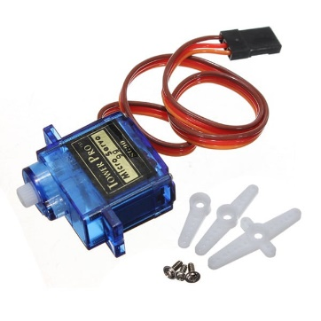It is a closed-loop system where it uses a positive feedback system to control motion and the final position of the shaft. Here the device is controlled by a feedback signal generated by comparing output signal and reference input signal. A servo consists of a Motor (DC or AC), a potentiometer, gear assembly, and a controlling circuit. First of all, we use gear assembly to reduce RPM and to increase torque of the motor. Say at initial position of servo motor shaft, the position of the potentiometer knob is such that there is no electrical signal generated at the output port of the potentiometer. Now an electrical signal is given to another input terminal of the error detector amplifier.

**ESP32**

ESP32 is created by Espressif Systems with a series of SoC (System on a Chip) and modules which are low cost with low power consumption.This new ESP32 is the successor to the well-known ESP8266(became very popular with its inbuilt WiFi). ESP32 not only has Built in WiFi but also has Bluetooth and Bluetooth Low Energy. In other words we can define ESP32 as “ESP8266 on Steroids”.ESP32 chip ESP32-D0WDQ6 is based on a Tensilica Xtensa LX6 dual core microprocessor with an operating frequency of up to 240 MHz

It achieves very low power consumption through power saving features including clock synchronization and multiple modes of operation. The ESP32 chip’s quiescent current is less than 5 μA which makes it the ideal tool for your battery powered projects or IoT applications .

